Uganda

## GNI per capita and development level

The data set shows the GNI per capita and development level of the country each year.

## # A tibble: 19 x 5  
## country iso3c date GNIperCapita devCategory  
## <chr> <chr> <dbl> <dbl> <chr>   
## 1 Uganda UGA 1996 500. Low Income   
## 2 Uganda UGA 1998 524. Low Income   
## 3 Uganda UGA 2000 542. Low Income   
## 4 Uganda UGA 2002 580. Low Income   
## 5 Uganda UGA 2003 599. Low Income   
## 6 Uganda UGA 2004 616. Low Income   
## 7 Uganda UGA 2005 633. Low Income   
## 8 Uganda UGA 2006 682. Low Income   
## 9 Uganda UGA 2007 721. Low Income   
## 10 Uganda UGA 2008 760. Low Income   
## 11 Uganda UGA 2009 791. Low Income   
## 12 Uganda UGA 2010 809. Low Income   
## 13 Uganda UGA 2011 858. Low Income   
## 14 Uganda UGA 2012 858. Low Income   
## 15 Uganda UGA 2013 860. Low Income   
## 16 Uganda UGA 2014 873. Low Income   
## 17 Uganda UGA 2015 890. Low Income   
## 18 Uganda UGA 2016 897. Low Income   
## 19 Uganda UGA 2017 891. Low Income

## GDP growth and economic growth classification

The data set shows the GDP growth and the ecomic growth classification of the country each year.

## # A tibble: 19 x 5  
## country iso3c date GDPannualGrowthRate GDPgrowthCategory4  
## <chr> <chr> <dbl> <dbl> <fct>   
## 1 Uganda UGA 1996 9.07 fast growth   
## 2 Uganda UGA 1998 4.91 moderate growth   
## 3 Uganda UGA 2000 3.14 moderate growth   
## 4 Uganda UGA 2002 8.73 fast growth   
## 5 Uganda UGA 2003 6.47 fast growth   
## 6 Uganda UGA 2004 6.81 fast growth   
## 7 Uganda UGA 2005 6.33 fast growth   
## 8 Uganda UGA 2006 10.8 fast growth   
## 9 Uganda UGA 2007 8.41 fast growth   
## 10 Uganda UGA 2008 8.71 fast growth   
## 11 Uganda UGA 2009 6.80 fast growth   
## 12 Uganda UGA 2010 5.64 fast growth   
## 13 Uganda UGA 2011 9.39 fast growth   
## 14 Uganda UGA 2012 3.84 moderate growth   
## 15 Uganda UGA 2013 3.59 moderate growth   
## 16 Uganda UGA 2014 5.11 moderate growth   
## 17 Uganda UGA 2015 5.19 moderate growth   
## 18 Uganda UGA 2016 4.78 moderate growth   
## 19 Uganda UGA 2017 3.81 moderate growth

## Development trend

The plot shows the development trend of the country.

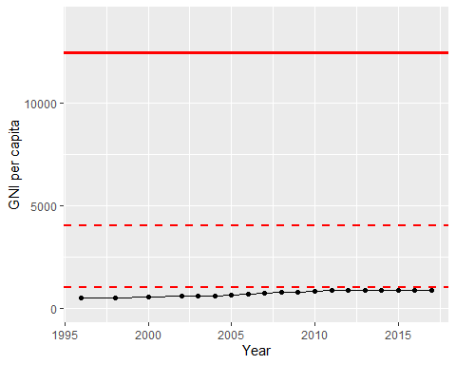

GNI Per Capita Trend